EE 332 Digital Communication
Project
Shreyash S Bharati
220102094

Flow Diagram :
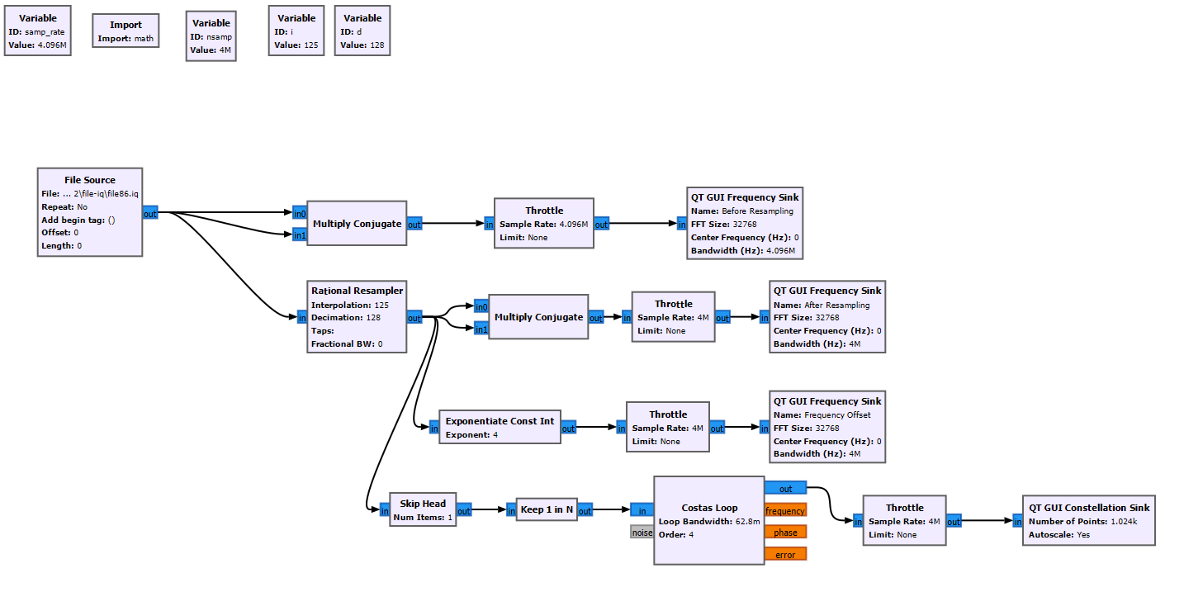
Techniques Used :
1] Obtaining the symbol rate : Multiplied the signal r(nTs) with its conjugate r*(nTs) and using FFT sink obtained peaks at intervals of 1/T from centre frequency (0Hz).
2] Resampling : As I was getting fractional sample per symbols, I had to resample my data to a new frequency.
3] Obtaining constellation scheme : Used Costa’s Loop for carrier recovery while checking for the sample with minimum ISI.
4] Obtaining frequency offset : Exponentiated the signal according to the constellation scheme and took the FFT to observe shift in the original spectrum and the exponentiated spectrum.
Calculations :
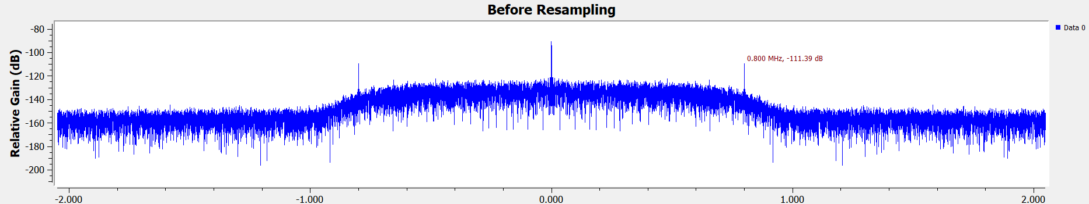
The peaks were obtained at 0.8MHz and hence the symbol rate=0.8MHz. Here, sampling frequency Fs=4.096MHz.
Samples per symbol=4.096/0.8=5.12 which is fractional.
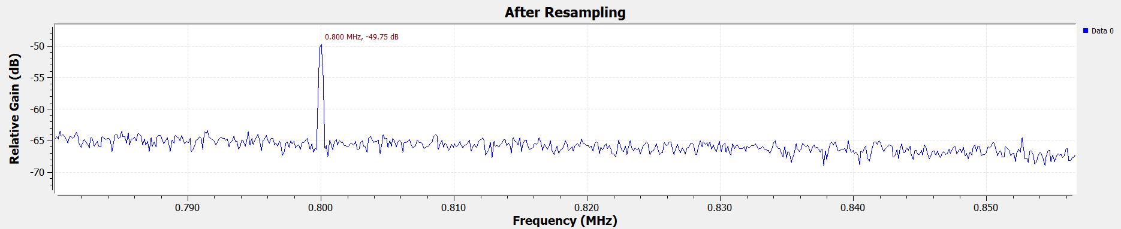So, lowering Fs to 4MHz gave 5 samples per symbol.
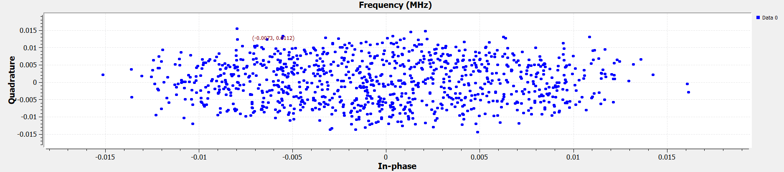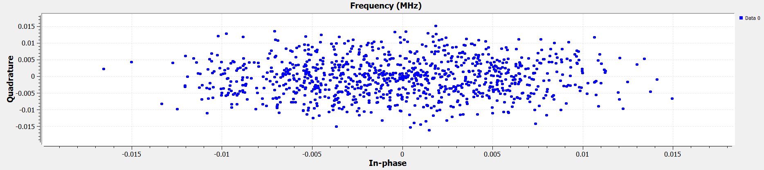
Skip head=2 Skip head=3
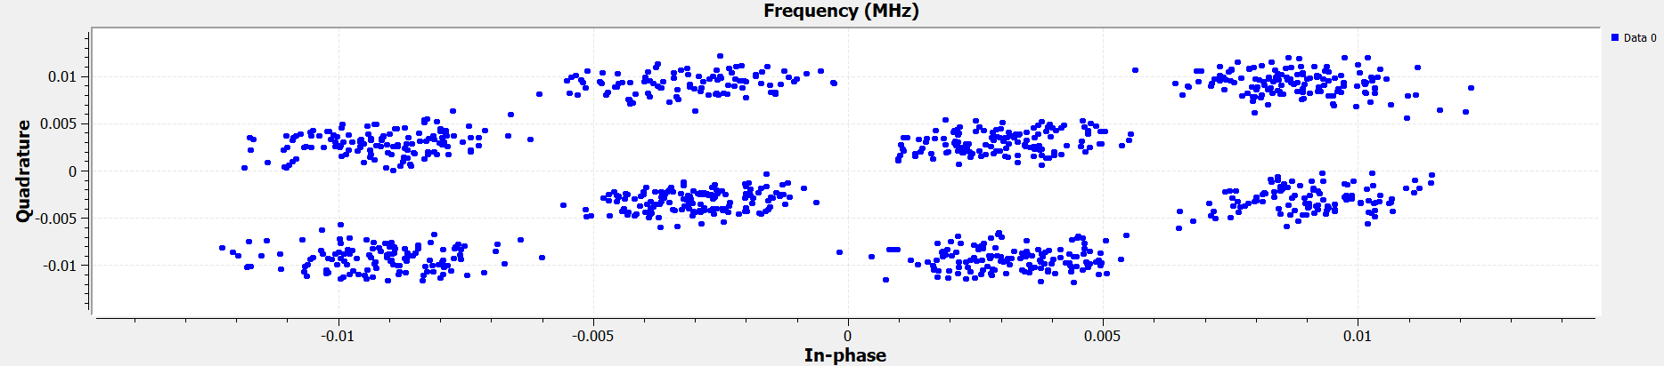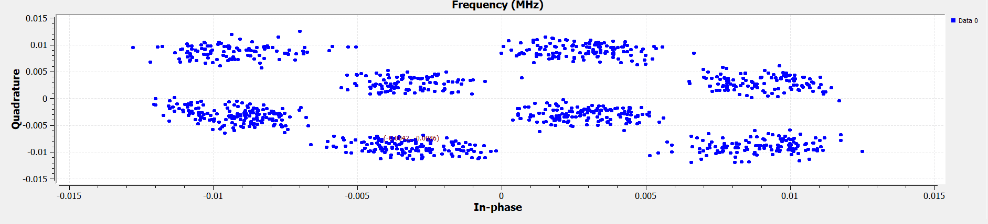
Skip head=5 Skip head=1
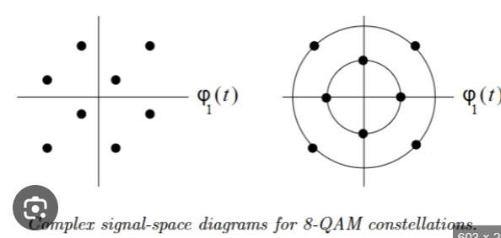
Then, using Costa’s Loop the constellation scheme was obtained as 8-QAM.
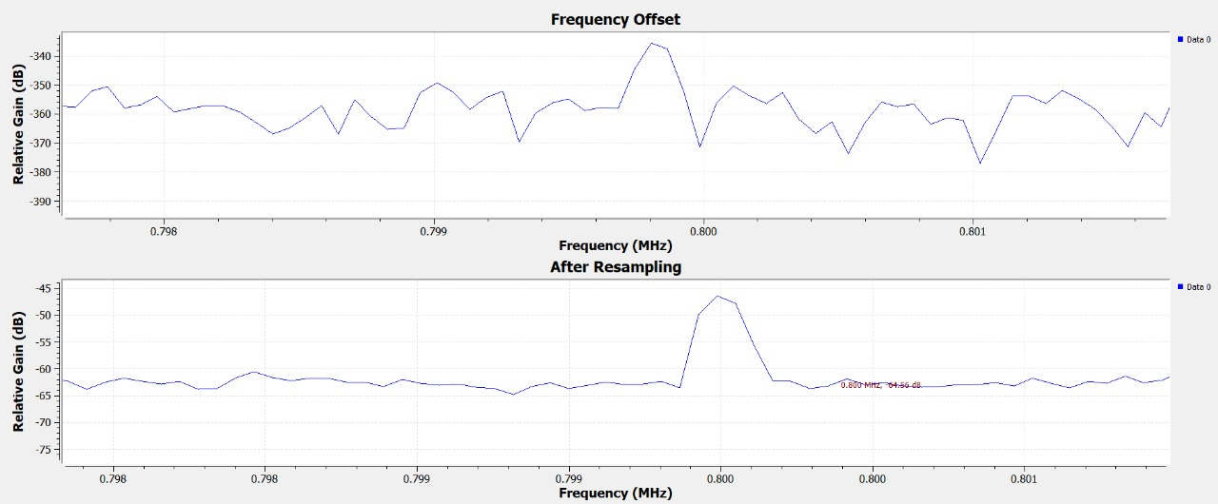Now, keeping the exponent value as 8, the frequency shift was obtained as 0.8-0.7996=0.0004MHz=400Hz.
Hence, q$∆$f=400 and q=8. Therefore, $∆$f=50Hz.
Results:
Symbol Rate | 0.8MHz=800kHz
Samples per symbol | 5
Constellation Scheme | 8-QAM
Frequency Offset | 50Hz

